FFR Test Program

Version: 1.4  
Valid from: 2024—02-16

# Introduction

This document outlines the tests needed to verify the compliance of FFR providing entities. The document also serves as a template for a test program.

Note that this is a translation of the Swedish document Testprogram FFR. In case of any inconsistency between the Swedish and English version, the Swedish version shall prevail.

# Summary of the technical requirements for FFR

A complete review of the technical requirements can be found in ”Technical Requirements for Fast Frequency Reserve Provision in the Nordic Synchronous Area” Version 1.1 at www.svk.se

## FFR support duration

There are two different FFR support durations alternatives specified in Table 1.

Table 1. FFR support duration

|  |  |
| --- | --- |
| **Alternative** | **Requirement** |
| Long support duration | At least 30 seconds |
| Short support duration | At least 5 seconds |

## Activation

The requirements on frequency activation level and maximum full activation time are the same for both long and short support duration FFR. There are three alternatives for the combination of frequency activation level and full activation time.

Table 2. Alternatives for the activation of FFR

|  |  |  |
| --- | --- | --- |
| **Alternative** | **Activation level [Hz]** | **Maximum full activation time [s]** |
| A | 49.7 | 1.30 |
| B | 49.6 | 1.00 |
| C | 49.5 | 0.70 |

## Overdelivery

The maximum acceptable overdelivery is 20 % of the prequalified FFR capacity, see Figure 1.

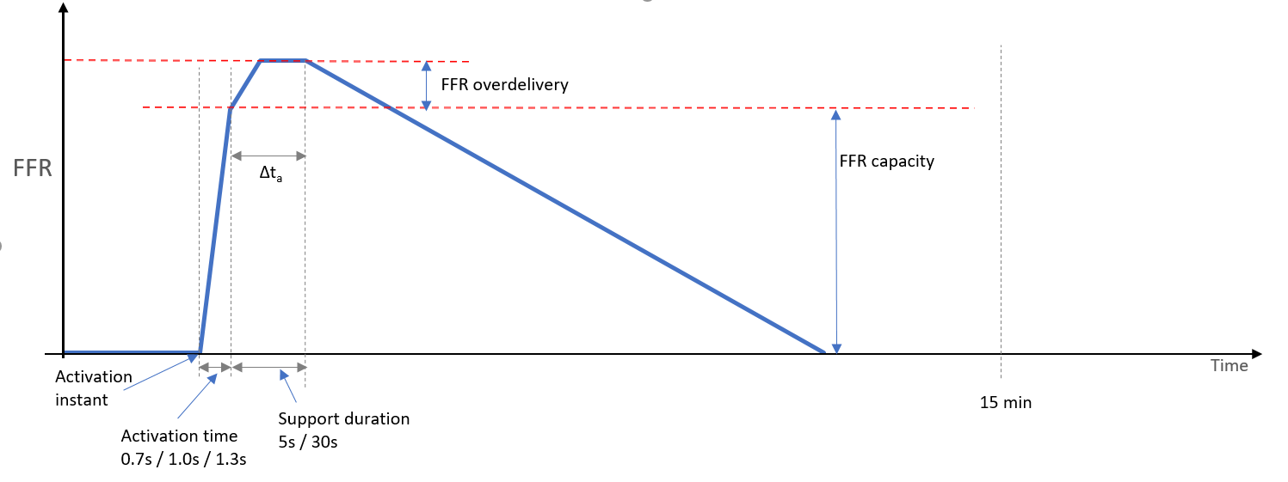

Figure 1. Definition of prequalified FFR capacity, over-delivery, activation time and support duration.

## Deactivation

The two different support durations have different requirements on the speed of deactivation in accordance with the table below.

Table 3. Deactivation

|  |  |
| --- | --- |
| **Alternative** | **Requirement** |
| Long support duration FFR | There is no limitation on the rate of deactivation for the long support duration FFR; the deactivation can be stepwise. |
| Short support duration FFR | The rate of deactivation is limited to maximum 20 % of the prequalified FFR capacity per second. |

## Recovery and Repeatability

A FFR providing unit/group that has been activated must be fully prepared for a new activation cycle within 15 minutes from the start of the first activation. The recovery should be demonstrated in the maximum capacity test.

There are requirements for when the recovery are allowed to start:

For the short support duration, recovery may not begin until the total time of activation time (0.7-1.3 s) plus endurance time (5 s) plus minimum deactivation time (5 s) plus 10 seconds has elapsed from the start of activation.

This is illustrated in Figure 2 below.

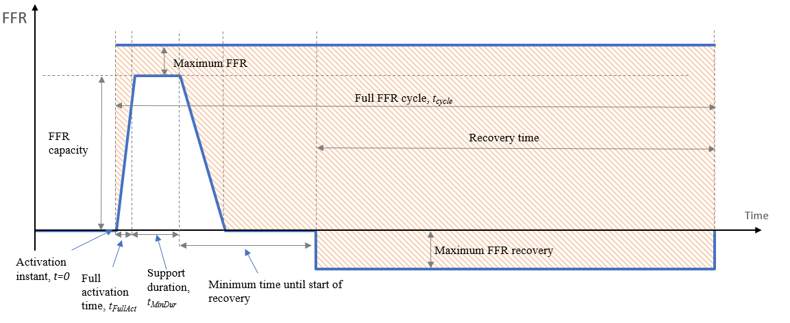

Figure 2. FFR recovery requirement for short duration FFR; activation at t=0.

For the long support duration, recovery may not begin until the total time of activation time (0.7-1.3 s) plus endurance time (30 s) has elapsed from the start of activation. This is illustrated in Figure 3 below.

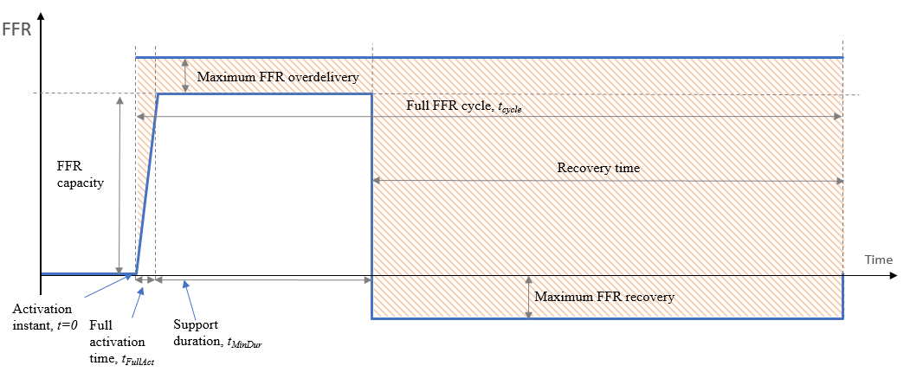

Figure 3. FFR recovery requirement for long duration FFR; activation at t=0.

## Active power measurement accuracy

The requirement for active power measurement accuracy depends on the rated power of the unit, see Table 4.

Table 4. Active power measurement accuracy

|  |  |  |
| --- | --- | --- |
| **Category** | **Rated Power** | **Accuracy** |
| 1 | <2 MW | $±$ 5 % |
| 2 | 2-10 MW | $±$ 1 % |
| 3 | >10 MW | $±$ 0,5 % |
|  |  |  |

# Planning for prequalification

Prior to performing the prequalification tests, the applying company should en-sure compliance with the following bullet points. When necessary, contact with Svenska kraftnät should be established well in advance.

* Ensure that latest version of all documents are used. Information and documents are available on Svenska kraftnät’s web site.
* Ensure that all information requested in the application document are available.
* Svenska kraftnät has the right to send an observer to the tests. Ensure that dialogue regarding the eventually presence of Svenska kraftnät’s observer is carried out in good time, at least 3 weeks prior to the tests with the responsible person part at Svenska kraftnät (ffr@svk). The responsible person part at Svenska kraftnät can ask the applying company to move the test time so that participation can be possible for Svenska kraftnät’s observer.
* The applying company is responsible for the costs incurred during the tests and has to provide the equipment needed. Svenska kraftnät is only responsible for its own costs.
* Ensure that any limitations have been approved by Svenska kraftnät before proceeding with tests.
* Decide the capacity interval for which the unit or group should be prequalified for.
* Note that separate tests must be made for each end-point of the interval. If the capacity for FFR exceeds 10 MW a test in the middle of the capacity range shall also be performed (roughly 40-60%).
* If the resource can only deliver a fixed capacity, the resource only needs to be tested for that level. Therefore, delivery must only take place for that specific capacity level.
* Ensure that data can be registered continuously during delivery in accordance with the table below.

Table 5. Summary of minimal requirements for registration and measurements

|  |  |  |  |
| --- | --- | --- | --- |
|  | Accuracy | Resolution | Sample time |
| Instantaneous  active power | Depending on relevant category according to Tab le 4 | 0,01 MW | 0,1 s |
| Measured  frequency | 10 mHz | 10 mHz | 0,1 s |
| Applied  frequency | 10 mHz | 10 mHz | 0,1 s |

# Preparing the tests

Prior to performing tests, the following points should be checked.

* The unit or group should be set up such that normal frequency measurement input is replaced by an artificial frequency source.
* Ensure that the data outlined below is logged and saved. Note also separate instruction ” Real time telemetry of measured values for units and groups providing FFR”.
* Ensure that logging equipment is correctly time synchronized.

Table 6. Summary of measurements and logging during the test.

|  |  |
| --- | --- |
| Measurement data | Unit |
| Instantaneous active power | MW |
| Calculated available power | MW |
| Applied frequency signal | Hz |
| Activated FFR capacity | 0/1 |
| Measured charge level  (State of charge) | % |

In addition, it is recommended that important states that may be affecting the tests be logged as well. Such data includes but is not limited to:

* Status id indicating which controller parameter set is active, if this can be changed automatically during the test.
* Controller’s output signal

For hydro units

* Guide vane opening
* Runner blade angle (Kaplan units)
* Upstream water level above sea level [m]
* Downstream water level above sea level [m]

For thermal units

* Turbine’s control valve opening

For wind unit

* Wind speed [m/s]

For solar units

* Solar radiation [W/m2]

For batteries

* Charge level (SOC)

# Prequalification test

Results from the test shall be presented in the designated test report and be   
attached to the application along with logged test data. There are two possible test methods to use in performing the FFR prequalification. Moreover, the test can either be conducted by a step response test or a ramp response test. Which tests that needs to be performed depending on the test method chosen are shown in Table 7.

Table 7. Summary of which test that needs to be performed depending on the test methods chosen.

|  |  |  |  |
| --- | --- | --- | --- |
| **Alternative 1:**  **Capacity test - Step response test and Test method 1.** | **Alternative 2:**  **Capacity test - Step response test and Test method 2.** | **Alternative 3:**  **Capacity test - Ramp response test and Test method 1.** | **Alternative 4:**  **Capacity test - Ramp response test and Test method 2.** |
| Step response test max- capacity:   * Test method 1   *(One test in total)* | Step response test max- capacity:   * Test method 2a * Test method 2b   *(Two test in total)* | Ramp response test max- capacity:   * Test method 1   *(One test in total)* | Ramp response test max- capacity:   * Test method 2a * Test method 2b   *(Two test in total)* |
| Step response test min- capacity (if prequalifying an interval):   * Test method 1   *(One test in total)* | Step response test min- capacity (if prequalifying an interval):   * Test method 2a * Test method 2b   *(Two test in total)* | Ramp response test min- capacity (if prequalifying an interval):   * Test method 1   *(One test in total)* | Ramp response test min- capacity (if prequalifying an interval):   * Test method 2a * Test method 2b   *(Two test in total)* |
| Step response test mid- capacity (if max capacity larger than 10 MW see 4.2):   * Test method 1   *(One test in total)* | Step response test mid- capacity (if max capacity larger than 10 MW see 4.2):   * Test method 2a * Test method 2b   *(Two test in total)* | Ramp response test mid- capacity (if max capacity larger than 10 MW see 4.2):   * Test method 1   *(One test in total)* | Ramp response test mid- capacity (if max capacity larger than 10 MW see 4.2):   * Test method 2a * Test method 2b   *(Two test in total)* |

## Test methods – Generating frequency signal

### Test method 1 – External synthetic frequency signal



Figure 4. Test with external synthetic frequency signal.

### Test method 2a – Internal synthetic frequency signal



Figure 5. Test with internal synthetic frequency signal.

### Test method 2b – Natural system frequency test signal



Figure 6. Test with actual system frequency measurement with adjusted frequency activation level

Test method 2b is intended as a complement to test method 2a. The test method 2b means that the trigger level for activating FFR is adjusted close to the current system frequency so that the resource will be activated by normal frequency variations. Thus, all parts of the activation process are tested except the activation level itself, which is tested in test method 2a. It is important to state the trigger level chosen here so that Svenska kraftnät can evaluate the test results.

## Capacity test

Capacity test should be performed for all units or groups.

Perform either a ramp or step response sequence for frequency according to Figure 4 or 5 and 6 with the selected frequency threshold for activating FFR. The ramp or step response must be performed from a starting frequency in the range of 49.9–50.1 Hz.

If the prequalification refers to a capacity interval, repeat the step- or ramp response tests, as well as the calculation of capacity and over delivery for the endpoints in the interval, i.e. maximum and minimum capacity. If the capacity for FFR exceeds 10 MW a test in the middle of the capacity range shall also be performed (roughly 40-60%).

### Step response test

For step response tests according to Figure 7, two steps must be used. FFR must be activated within a frequency band of +/ − 0.05 Hz around the selected frequency threshold for activation. This means that after the first step, FFR should not be activated, and after the second step, FFR should be activated.

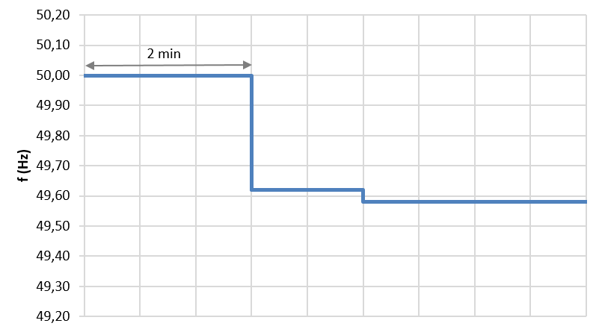

Figure 7. FFR step response sequence, example for activation level 49.6 Hz. First step is performed to a level just above the resource is activated, then another step just below the activation threshold.

### Ramp response test

If a ramp response test is performed according to Figure 8, the ramp speed is not critical but must not be faster than −0.2 Hz/s in order for it to be possible to obtain the frequency level at the time of activation. As with the step response test, FFR must be activated within +/ − 0.05 Hz around the frequency threshold for activation.

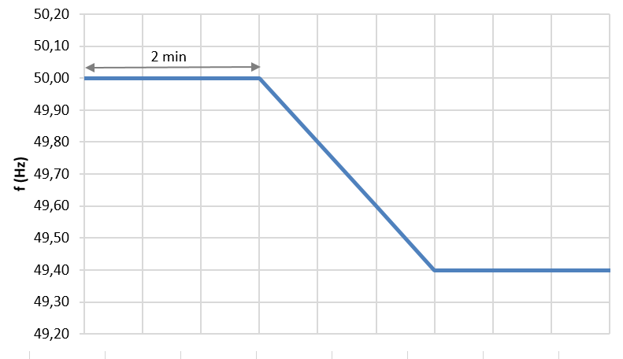

Figure 8. FFR ramp response test.

### Calculation of prequalified capacity

Prequalified FFR capacity is the smallest volume of FFR from the tested unit within the time interval Δta, see Figure 1 and mathematically expressed according to Equation 1.

$C_{pre-qual}= min(abs\left(P\left(t\right)-P\left(0\right)\right))$ [MW] [eq. 1]

Table 9. Variables in equation 1 explained.

|  |  |
| --- | --- |
| Variable | Description |
| $$C_{PreQual}$$ | Prequalified FFR capacity [MW] |
| $$P(t)$$ | Active power exchange between the grid and the providing entity [MW] |
| $$P(0)$$ | Baseline for active power |
| $$t$$ | Time where 𝑡 ∈ {[𝑡𝐹𝑢𝑙𝑙𝐴𝑐𝑡 , 𝑡𝐹𝑢𝑙𝑙𝐴𝑐𝑡 + 𝑡𝑀𝑖𝑛𝐷𝑢𝑟 ]} |
| $t_{FullAct}$ | Maximum activation time (specified for the providing entity according to technical requirements 0.70, 1.00, or 1.30 s) |
| $$t_{MinDur}$$ | Minimum duration time (specified for the providing entity according to technical requirements 5.0 or 30 s) |

### Calculation of over delivery of prequalified FFR

The maximum permitted over delivery of FFR capacity is 20 % of prequalified FFR capacity, see Figure 1. The over delivery of FFR is the difference between the maximum delivered FFR capacity in the time interval *tcycle* and the prequalified FFR capacity expressed as a percentage of prequalified FFR capacity. Mathematically expressed according to Equation 2.

${FFR}_{OS}= 100×\frac{max⁡( P\left(t\right)-P\left(0\right)-C_{PreQual})}{C_{PreQual}} [\%]$ [eq. 2]

|  |  |
| --- | --- |
| Variable | Description |
| $${FFR}_{OS}$$ | Overdelivery of FFR [%] |
| $C_{PreQual}$ | Prequalified FFR capacity [MW] |
| $P(t)$ | Active power exchange between the grid and the providing entity [MW] |
| $$P(0)$$ | Baseline for active power |
| $t$ | Time where 𝑡 ∈ {[ tFullAct, 𝑡cycle ]} |
| $$t_{FullAct}$$ | Maximum activation time (specified for the providing entity according to technical requirements 0.70, 1.00, or 1.30 s) |
| $t_{cycle}$ | Time to complete an entire FFR activation cycle, including activation, deactivation, and recovery. |

## Active measurement of frequency

Perform a test with at least 1 hour of measuring active frequency.

## Evaluation of forecasted bid capacity and baseline

If the power from the unit or group varies depending on surrounding conditions, at least 2 month of logged data (*Reporting of measurements for units and groups participating with variable production and consumption*), should be attached to the application. The logged data should include at least 300 hours of bids. Data should be logged and sent in the format specified in *Reporting of measurements for units and groups participating with variable production and consumption*:

*Note,* depending on the accuracy of the baseline the minimum capacity could be adjusted during the evaluation of the prequalification application.

# Exceptions for prequalification tests for the 2024 procurement of FFR

For the 2024 procurement of FFR, some exceptions are allowed as described below. These exceptions only apply for the contract period that the 2024 procurement covers. For future contract periods and procurements the requirements below will not be excluded.

## Requirements on real-time communication with Svenska kraftnät

For the 2024 procurement no real-time communication with Svenska kraftnät are required. Instead, the FFR provider must continuously log real-time measurements and afterwards send that documentation to Svenska kraftnät for verification.

Logging and reporting measurement should be done in accordance to the separate instruction “*Real time telemetry of measured values for units and groups providing FFR*”. Sampling time for logging data shall not exceed 0.1 seconds.

Table 7. Signals used for logging of real time measurements

|  |  |
| --- | --- |
| Information | Unit |
| Available capacity FFR [MW] | MW |
| Measured Active Power [MW] | MW |
| Measured grid frequency | Hz |
| Activated FFR capacity (0 or 1 where 1 indicates that FFR has been activated) | 0 or 1 |
| Measured charge level  (State of charge) | % |
|  |  |

# Data format

In order for Svenska kraftnät to be able to review submitted data as smoothly and objectively as possible, the process for this is partially automated. Formatting and file names must therefore follow the specifications described below.

Data is delivered in csv format (character encoding UTF-8), values ​​separated by comma (,) and decimals indicated by decimal point (.). Lines are separated by line breaks (↵ ASCII/CRLF=0x0D 0x0A). File names must be in the format [Resource]_[Service]_[Area]_[Interval]_[Sampling_rate]_[Date].csv, where the sub-elements are specified as follows:

* Resource = Designation for the resource.
* Service = Support service that the log file includes in this case FFR.
* Area = Bid ​​area for the unit/group. The bid range can be either SE1, SE2, SE3 or SE4.
* Interval = Time interval that the log file covers, specified in the format YYYYMMDDThhmm-YYYYMMDDThhmm.
* Sampling rate = Nominal time difference between samples specified in milliseconds.
* Date = Date when the log file was compiled to be sent to Svenska kraftnät, specified in the format YYYYMMDD.

Example file names:

UnitG1_FFR_SE3_20200515T0000-20200601T2359_100ms_20200602.csv

Data points in the csv file are formatted as follows:

DateTime,FfrCap,InsAcPow, …

[DateTime1],[record1_1],[record1_2], … ,[record1_X]

[DateTime2],[record2_1],[record2_2], … ,[record2_X]

etc.

Columns to be included are specified below, including header row and data type.

Columns that are not applicable should be left blank.

* DateTime = Date and time in the format YYYYMMDDThhmmss.nnn, where n are decimals of a second, e.g. 20200601T093702.012
* FfrCap = Available capacity FFR in [MW], specified as a double with at least two decimal places, e.g. 20.10. Available capacity refers to the actual delivery that will take place in the event of a disturbance, normally the sum of the intended delivery and any additional delivery.
* InsAcPow = Instantaneous measured active power in [MW], specified as a double with at least two decimal places, e.g. 120.53
* GridFreq = Measured grid frequency in [Hz], specified as a double with at least two decimal places, e.g. 49.32
* ContOutSig = control signal for activation (i.e. trigger condition met and delivery profile in progress), boolean indicator [1/0] with activated (=1) or not activated (=0), e.g. 1.
* SoC = measured charge level ("State of charge") stated as a percentage [%] with at least two decimal places in the format double, e.g. 30.00.
* Reference value (baseline) active power in [MW], specified as a double with at least three decimal, , e.g. 120.500

The following columns are optional for the 2023-2024 season. If included, they should follow the format below:

* ContSetP = The regulator's setpoint for active power before delivery of FFR in [MW], specified as a double with at least two decimal places, e.g. 67.50
* ContMode = alphanumeric designation for used control mode, e.g. FFR4

An example of how a csv file should be structured is shown in *Figure* *9*.

DateTime, FfrCap, InsAcPow, GridFreq, ContOutSig, ContSetP, SoC, RefAcPow

20200601T093702.012,20.10,120.53,49.91,0,67.50,9.05,120.100

20200601T093702.112,20.10,120.53,49.49,1,67.50,99.05,120.100

20200601T093702.212,20.10,110.33,49.48,1,67.50,98.90.120.100

20200601T093702.312,20.10,101.04,49.49,1,67.50,98.58,120.100

*Figur 9. Example of how the logged data should be reported. The example does not include ContMode as this column is optional.*