FCR-D down Test program

Version: 6.0  
Valid from: 2023-06-01

# Introduction

This document outlines the tests needed to verify the compliance of FCR-D down providing entities [1]. The document also serves as a template for a test program.

Note that this is a translation of the Swedish document, *Testprogram FCR-D ned 6.0,* in case of any inconsistency between the Swedish and English version, the Swedish version shall prevail.

# Planning for prequalification

Prior to performing prequalification tests, the applying company should assure compliance with the following bullet points. Establish contact with Svenska kraft-nät well in advance when necessary.

* Take note of current regulations stated in current balance responsible agreement and in the technical requirements *Technical Requirements for Frequency Containment Reserve Provision in the Nordic Synchronous Area* [1].
* Ensure that latest version of all documents are used. Information and documents are available on Svenska kraftnäts website.
* Ensure that all information requested in the application document are available.
* Svenska kraftnät has the right to send an observer to the test facility. Ensure to contact the responsible part at Svenska kraftnär ([fcr@svk.se](mailto:fcr@svk.se)) 3 weeks in advance. The responsible part at Svenska kraftnät may ask the applying company to arrange the tests another day in order to be able to participate during the tests. The applying company is responsible for the costs incurred during the tests and has to provide the equipment needed. Svenska kraftnät is only responsible for its own costs.
* Ensure that Svenska kraftnät has approved identified limitations before the tests are initiating.
* Decide which operations ranges the entity is to be prequalified for, and associated range for capacity and droop. Note that separate test for each end-point of the interval should be performed. If only operational condition are tested, delivery is only allowed at that point.
* Consider if the parameter settings are such that the dynamic behavior of the controller is scaled linearly with the gain (1/ep).
* Ensure that IT-tool provided by Svenska kraftnät, where he provider chooses to use it, is the latest version.
* Investigate the need for preforming additional tests due to special considerations. For example:
  + Separate test the frequency measurement loop when using an internal governor software for testing.
* Ensure that logged data can be provided during FCR provision, according to table 1 and 2.

Table 1. Requirements for active power and frequency.

|  |  |  |  |
| --- | --- | --- | --- |
|  | Category | Rated power[1] | Accuracy |
| Instantaneous active power | A | < 1.5 MW | 5 % |
| B | 1.5 -10 MW | 1 % |
| C +D | >10 MW | 0.5 %[2] |
| Measured frequency | - | - | 10 mHz |
|  |  |  |  |

Table 2. Requirements for resolution and sampling time during normal operations.

|  |  |  |
| --- | --- | --- |
|  | Resolution | Sample time |
| Instantaneous active power | 0.01 MW or 0.025 %[3] | 1 s |
| Measured frequency | 5 mHz | 1 s |
|  |  |  |

# Preparing the tests

Verify below points before performing the tests.

* Replace the normal frequency measurement input with an artificial frequency source for the unit or group.
* The testing shall preferably be performed by using external equipment as the artificial frequency source, connected to the frequency meter, and instead of using a test signal generated in the governor. If an externa signal is not feasible, an internal signal may be used, but then additional testing of the frequency measurement loop has to be performed as described in section 3.4.
* Ensure that logging equipment is correctly time synchronized.
* Ensure that logged data can be provided during tests, according to Table 3 and section 5.

Table 3. Requirements for measurements and logging during the test.

|  |  |  |  |
| --- | --- | --- | --- |
|  | Unit | Resolution | Maximum sample time |
| Instantaneous active power | MW | 0.01 MW or 0.025% | 0.1 s |
| Calculated available capacity | MW | 0.01 MW or 0.025% | Once per test |
| Measured frequency | Hz | 5 mHz | 0.1 s |
| Applied frequency signal | Hz | 5 mHz | 0.1 s |
| Parameter settings, if these are changed during operation. | - | - | 0.1 s |
|  |  |  |  |

In addition, it is recommended that important states that may affect the test results are logged during the test. Such data includes but is not limited to:

For all units:

* Power baseline[4] [MW]
* Controller output signal

For hydro units:

* Guide vane opening
* Runner blade angle (Kaplan units)
* Upstream water level above sea level [m]
* Downstream water level above sea level [m]

For thermal units:

* Turbine control valve opening

For wind entities:

* Wind speed [m/s]

For solar entities:

* Solar irradiation [W/m2]

For batteries:

* Charge level (SOC)
* NEM (MW)
* AEM (on/off)

# Prequalification tests

This section contains specifications of the tests to be performed to prequalify an entity for FCR-D down provision. The tests and the specific operational conditions the tests are to be performed at is listed in Table 4.

If a provider only consider proving FCR-D down at one operational condition only that condition need to be tested.

Table 4. Prequalification tests for FCR-D down and at which operational conditions the tests are to be performed.

|  |  |
| --- | --- |
| Prequalification test FCR-D down | Operational conditions |
| Ramp response test | * High load, low droop * High load, high droop * Low load, load droop * Low load, high droop |
| Sine response test | * High load, low droop |
| Linearity test | * High load, low droop * Low load, high droop |
| Energy management test | * High load, low droop |

In addition to the tests listed above, the tests described in Table 5 with relevant operational conditions must be completed once for each tested entity.

Table 5. Prequalification tests for FCR

|  |  |
| --- | --- |
| Prequalification tests for FCR | Operational conditions |
| 1 test of the frequency measurement equipment, for entities tested with internal frequency signals. | * Any operational condition. |
| 1 hour of active FCR provision, using measured grid frequency. | * High load, low droop |

Results from the tests shall be attached to the application along with logged test data. The test results are evaluated by utilizing the IT-Tool provided by the TSOs.

## Ramp response test

The ramp response test shall be performed for all FCR-D down providing entities. The test is executed by performing a frequency ramp-response sequence as shown in Figure 1.

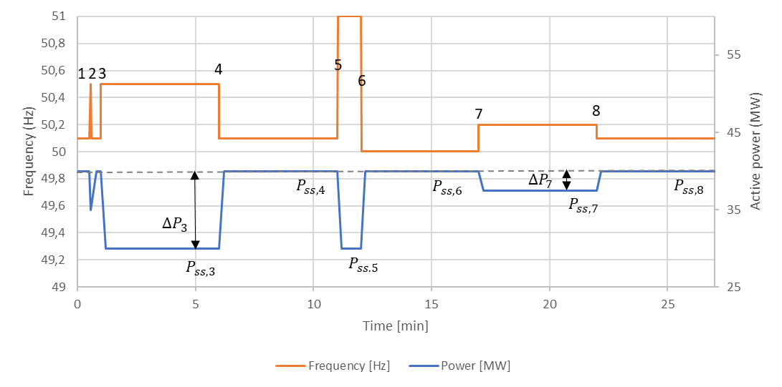

Figure 1. FCR-D down ramp response test. Here, FCR-N is inactive and therefore P8 = P6.

The ramp sequence for resources without limitation in energy reservoir are described in detail in Table 6.

Table 6. Ramp response test for FCR-D down.

|  |  |  |  |  |  |  |
| --- | --- | --- | --- | --- | --- | --- |
| Ramp number | Start time [s] | Duration [s] | Frequency [Hz] | Ramp rate [Hz/s] | Comments | If mode shift is used |
|  | 0 | 30 | 50.1 | 0 | Wait until the power is stable before starting the test. |  |
| 1 | 30 | 4.9 | 50.55 | 0.14 | Performance test 1. | Shift to high performance mode. |
| 2 | 34.9 | 55.1 | 50.1 | 0.09 | Deactivation test 1 | Return to stability mode. |
| 3 | 90 | 300 / 900 | 50.5 | 0.24 | Steady state response at full activation. | Performance mode blocked. |
| 4 | 390 | Min. 300 | 50.1 | 0.24 | Steady state response at zero activation. | Maintain at least until mode shift is unblocked. |
| 5 | 690 | 60 | 51.0 | 0.24 | Performance test 2. | Shift to high performance mode. |
| 6 | 750 | 300 | 50.0 | 0.24 | Deactivation test 2. | High stability mode (mode shift blocked) |
| 7 | 1050 | 300 | 50.2 | 0.24 | FCR-N/FCR-D combination test. |  |
| 8 | 1350 | 300 | 50.11 | 0.24 | FCR-N/FCR-D combination test. |  |

The ramps sequence shall be performed at all four operational conditions described in section 3 and Table 4. For entities that are providing both FCR-N and FCR-D down at the same time, FCR-N shall be active during the droop tests to test the combination of FCR-N and FCR-D down. The last two ramps (No. 7 and 8) need to be included only when testing the combined provision of FCR-N and FCR-D down. Entities with LFSM controllers shall have this active during the ramp response test.

For units without limited energy reservoirs ramp 3 shall be extended to 15 minutes to test endurance for one of the tests. The most challenging operational condition of droop and loading shall be chosen for this test. For units with limited energy reservoirs a separate test to test endurance is required, see section 3.2.

For providing entities with a non-continuous response only ramp 3 and 4 must be performed. For the most challenging operational condition ramp 3 should be 15 minutes (30 minutes for units with limited energy reservoirs). For the other operational conditions ramp 3 should be at least 60 seconds.

## Energy management test

Figure 2 illustrate the Energy management test for FCR-D down. The figure shows the input frequency, active power (% of FCR-D capacity) and state of charge. It further shows the reference frequency which changes when the AEM function is turned on and off. The reference frequency affects the output power as shown in the figure.

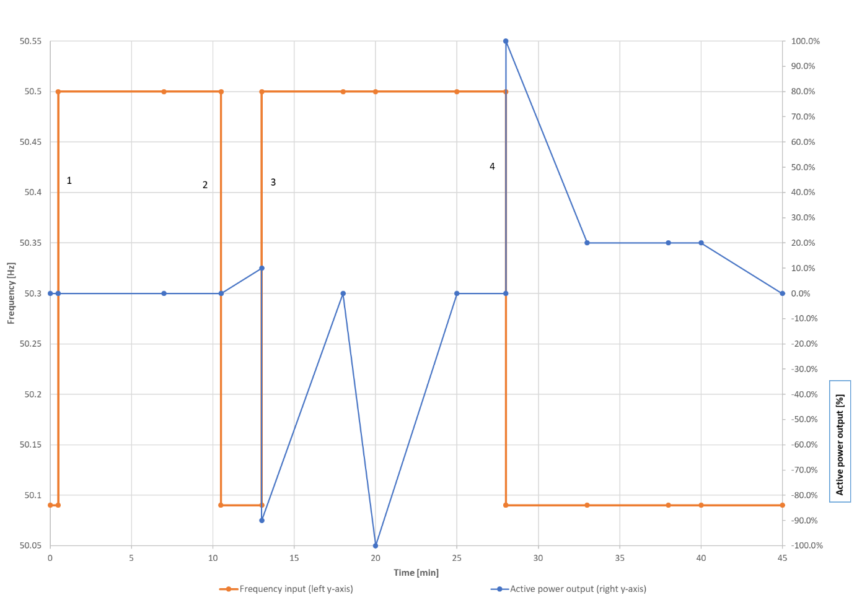

Figure 2. Energy management test of FCR-D down. NOTE: This is an example. Hence, NEM/AEM activations will vary dependent on specific MW/MWh capacities of the LER unit.

Table 7 describes the Energy management test for FCR-D down. The provider can freely choose the initial SOC, however it should not be in the intervals where NEM or AEM are turned on. The durations given in the table are minimum durations, with the exception for step 2 which should always be 2.5 minutes. The actual duration varies depending on the reservoir size and initial state of charge, and therefore the test must be adjusted to the specific unit.

Table 7. Energy management test for FCR-D down.

|  |  |  |  |  |  |
| --- | --- | --- | --- | --- | --- |
| Step  number | Minimum duration [min] | Frequency [Hz] | NEM | AEM | Comments |
|  | 30 | 50.09 | Off | Off | Wait until the power is stable before starting the test. |
| 1 | 600 | 50.5 | Off | Off | This step must be held at least for 10 minutes and until NEM turns on when going into normal frequency band (Step 2) |
| 2 | 150 | 50.09 | On | Off | NEM turns on due to entering of normal frequency band. The step should be 2.5 minutes. |
| 3 | 900 | 50.5 | Off | On | This step must be held 5 min after AEM turns on. |
| 4 | 900 | 50.09 | On  Off | Off | NEM must be turned on when stepping into the normal frequency band. The step must be held until NEM and AEM turns off. |

The step sequence should be performed for the most challenging operational condition, typically high load and low droop.

## Sine response test

The sine response test shall be performed for all FCR-D down providing entities.

In the sine response test the frequency varies accordingly:

, [5]

I.e. a sinus with the amplitude of 0.1 Hz around 50.3 Hz, and varying periods, T. For every new period, the sine response shall stabilize and then the number of stationary periods shall be logged. The required periods and the number of stationary periods are listed in Table 7 together with the recommended number of periods (though the total number of periods required to reach steady state depends on the design of the unit, and should be checked during test).

The provider of FCR-D down can chose to test more periods to evaluate the Transfer function in the area otherwise interpolated (see *Technical Requirements for Frequency Containment Reserve Provision in the Nordic Synchronous Area* [1].

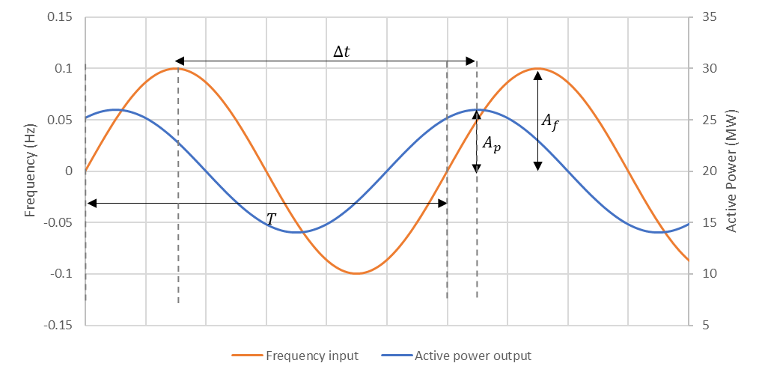

Figure 3. FCR-D down sine response test. Note that the figure only show one example of a period and note the whole test sequence.

Table 7. Specification of input signals for the sine response test for FCR-D down. The sines with 90, 150 and 300 second periods only need to be performed for entities that utilize mode shifting. If mode shifting are utilized and the same parameters are used for FCR-N as for FCR-D stability mode the test could be performed with 50.0 Hz as frequency (i.e. be performed in FCR-N mode).

|  |  |
| --- | --- |
| Period, T [s] | No. of stationary periods  (Recommended total No. of periods) |
| 10 | 5 (20) |
| 15 | 5 (15) |
| 25 | 5 (10) |
| 40 | 5 (7) |
| 50 | 5 (7) |
| 60 | 5 (7) |
| 70 | 5 (7) |
| 90 | 5 (7) |
| 150 | 3 (4) |
| 300 | 2 (3) |

The sine tests need only to be carried out at one operational condition. This should be the operational condition that are most challenging in regards to performance and stability (for FCR-D down this is typically the high loading and high droop settings). If the same parameter set is utilized for both FCR-D down and FCR-D up provision it is sufficient to do the sine response test for either FCR-D up or FCR-D down. The sines with 90, 150 and 300 second periods only need to be performed for entities that utilize mode shifting. For units with mode shifting high performance mode is evaluated and therefore it is important to use enough stationary periods, where mode shifting is blocked, are logged.

## Linearity test

The linearity test shall be performed for FCR-D down providing entities with a non-continuous response. The test is performed by applying a sequence of frequency steps of 100 mHz per step as shown in Figure 3. The test sequence will start at 50.1 Hz, move step wise up to 50.5 Hz and then back down to 50.1 Hz again. Each step shall be maintained for a duration of at least 120 seconds. The first 60 seconds allows the response to reach steady state and then the next 60 seconds are used for evaluation of the steady state response. If steady state is not reached within the first 60 seconds, the provider is allowed to wait longer (up to 5 minutes).

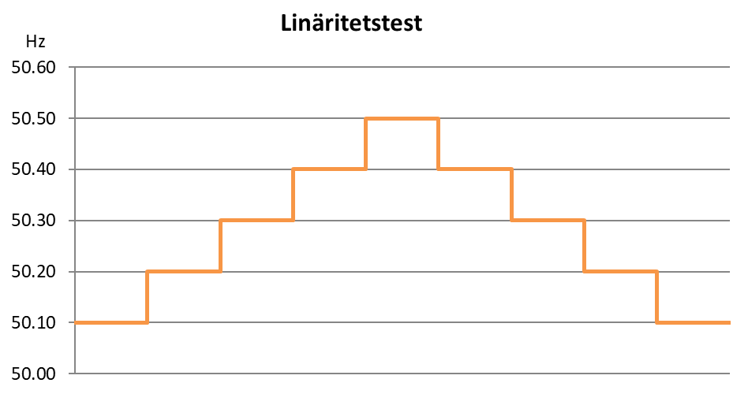

Figure 4. FCR-D down linearity test.

## Test of the frequency measurement equipment

If the frequency measurement equipment is omitted from the test process by e.g. applying an internal frequency signal to the controller, an approximate time constant, TFME, of the frequency measurement equipment needs to be separately determined using one of the below four options:

1. Separate test of the frequency measurement loop, by inserting an externally generated frequency step response to measure the time constant of the response. The test is shown in Figure 4.
2. Documentation from supplier of the equipment.
3. References to previous tests of equal equipment.
4. Using the default value provided by the TSOs , TFME=1.

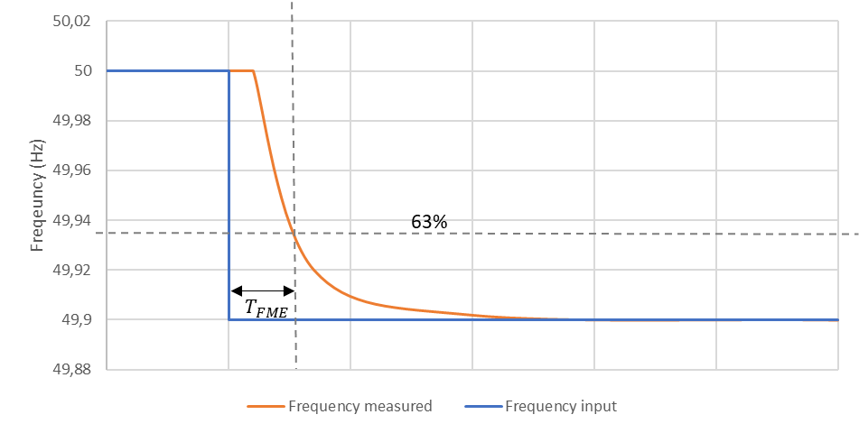

Figure 5. Test of frequency measurement equipment.

## Active FCR provision

Perform a test with 1 hour of active frequency control based on measured grid frequency. Use the same parameters as during the tests above. The test should, if possible, be performed at high load and low droop. If the application includes two or more reserves only one test is required, where at least one of the reserve is active, preferably FCR-N if it is included in the application.

# Test exemptions

The following exemptions are subject to Svenska kraftnät approval prior to testing:

* For technologies where power set point does not influence the FCR provision capabilities, testing at a single power set point is sufficient.
* Svenska kraftnät can give additional exemptions for testing requirements where compliance can be confirmed by the general knowledge of the technology, either from previous tests of similar entities or other documentation. The potential FCR provider is responsible for clarifying this prior to testing.

# Format for data logging

In order for Svenska kraftnät to be able to review submitted data as smoothly and objectively as possible, the process for this is partially automated. Formatting and file names should therefore follow the specifications below.

The file format for data delivery is the European standard csv-file, character en-coding in ASCII where values are delimited by comma (,), decimal separator is point (.) and record delimiter is carriage return (↵ ASCII/CRLF=0x0D 0x0A). Naming format for the file is [Re-source]_[Service]_[TestType]_[Area]_[Timezone].csv, where the sub-elements are denoted as follows:

* Resource = Identifier for the resource agreed with reserve connecting TSO.
* Service = Type of service. In this case FCRdDown.
* TestType = The type of test that the log file includes. E.g. RampTestHLLD, sineResponse10s, LinearityTestHLLD, LERTestLLHD. Table 9 in Appendix shows all different testtypes.
* Area = The bidding area where the unit or group is located e.g. SE1, SE2, SE3 or SE4.
* Timezone = The time zone used for logging, e.g. CET/CEST or UTC.

Example file name:

UnitG1_FCRdDown_ RampTestHLHD_SE3_UTC.csv

Data records are provided in the following format:

DateTime, InsAcPow, …

[DateTime1],[record1_1],[record1_2], … ,[record1_X]

[DateTime2],[record2_1],[record2_2], … ,[record2_X]

etc.

Columns to be included are specified below, including title bar and data type.

* DateTime = Date and time in format YYYYMMDDThhmmss.nnn, where n are decimal fractions of a second, e.g. 20200601T093702.302
* InsAcPow = Double with at least three decimals of instantaneous active power in MW, e.g. 120.532
* ApplFreqSig = Double with at least three decimals of applied frequency signal during test in Hz.
* GridFreq = Double with at least three decimals of measured grid frequency in Hz e.g. 50.000
* Cap_FcrdDo = Double with at least three decimals of calculated available capacity in MW e.g. 20.100
* NEM = Instantaneous active NEM power, double with at least three decimals [MW]8
* AEM = binary value indicating if the AEM is activated, e.g. 0 or 1[6]
* ContMode_FcrdDo = alphanumeric identifier of the control mode in use.
* ResSize_FcrdDo = Remaining endurance FCR-D down [minutes], double with at least three decimals6

An example of how a csv-file for step response test, linearity rest and sine response test[7] should be structured is shown in Figure 5*.*

DateTime,InsAcPow,ApplFreqSig,CalcFcrdCap,NEM,AEM,ResSize_FcrdDo

20200601T093702.302, 120.532, 50.000, 20.100, 0.000, 0, 10.000

20200601T093703.302, 120.532, 50.000, 20.100, 0.000, 0, 10.000

20200601T093704.302, 115.330, 50.000, 20.100, 0.000, 0, 10.000

20200601T093705.302, 111.040, 50.000, 20.100, 0.000, 0, 10.000

Figure 6. Example of how logged data shall be reported during a ramp response test and linearity test.

An example of how a csv-file for active regulation based on grid frequency should be structured is shown in Figure 6.

DateTime, InsAcPow, GridFreq

20200601T093702.302, 120.532, 50.000

20200601T093703.302, 120.532, 50.000

20200601T093704.302, 115.330, 50.000

20200601T093705.302, 111.040, 50.000

Figure 7. Example of how logged data shall be reported for active regulation based on grid frequency.

# References

|  |  |
| --- | --- |
| [1] | *Technical Requirements for Frequency Containment Reserve Provision in the Nordic Synchronous Area.* |

# Appendix

Table 8. Summary of all test for FCR-D down. For more information, see Table 22 in [1].

|  |  |  |  |
| --- | --- | --- | --- |
| Test type | Name (TestType) | Load | Droop |
| Ramp response test  FCR-D down | RampTestHLHD | High | High |
| Ramp response test  FCR-D down | RampTestHLLD | High | Low |
| Ramp response test  FCR-D down | RampTestLLHD | Low | High |
| Ramp response test  FCR-D down | RampTestLLLD | Low | Low |
| Sine response test FCR-D down | SineResponse10sHLLD  SineResponse15sHLLD  Etc. | High | Low |
| Linearity test FCR-D down | LinearityTestHLLD | High | Low |
| Linearity stest FCR-D down | LinearityTestLLHD | Low | High |
| Energy Manegemnt test | LERTestLLHD | Low | High |

1. Rated power for the unit or group tested.
2. If prequalified for the first time prior to the end of 2023, ± 1 % is allowed. This exemption shall continue to apply only until the next substantial change of the equipment.
3. For new installations it is recommended to use a 16-bit transducer and thus have a resolution of 0.0015%.
4. The power baseline can either be the power set point of the entity, or, if there is no power set point, a calculated value corresponding to the expected power output if frequency control was inactive.
5. If mode shifting are utilized and the same parameters are used for FCR-N as for FCR-D stability mode the test could be performed with 50.0 Hz as nominal frequency (i.e. be performed in FCR-N mode).
6. Only for unit or groups with limited energy reservoirs (LER).
7. In the sine response test the CalcFcrnCap is not necessary to log.