aFRR Test Program

Version: 2.1

Valid from: 2024-05-01

# Introduction

This document describes the tests required for verifying that the units or groups providing aFRR fulfil stated requirements. This document also functions as a template for a test program.

Note that this is a translation of the Swedish document *Testprogram aFRR 2.0* in case of any inconsistency between the Swedish and English version, the Swedish version shall prevail.

# Summary of aFRR technical requirements

For a full review of the technical requirements, see "Approval Process for delivery of Frequency Restoration Reserves to Nordic TSOs" version one found at [Förkvalificering | Svenska kraftnät (svk.se)](https://www.svk.se/aktorsportalen/systemdrift-elmarknad/information-om-stodtjanster/forkvalificering/).

Since publishing the Nordic document, the aFRR product has undergone changes. The information in this document complements the Nordic document. In the event that the requirements in these two differ, the requirements described in this document take precedence.

## 1.1 Accuracy

The aFRR response of a unit or group must remain within the permitted steady state error margins throughout the period the unit or group provides aFRR. Depending on the capacity, which the aFRR resource is prequalified for, the permitted margin will vary, in accordance with Table 1.

Table 1: Permitted steady state error margins.

|  |  |  |
| --- | --- | --- |
| **Category** | **Prequalified aFRR capacity** | **Maximum permitted steady state error** |
| 1 | <10 MW | $±$ 10% of the setpoint change |
| 2 | >10 MW | ±1 MW |
|  |  |  |

## 1.2 Response delay

The response delay time is defined as the time it takes from Svk having sent a new setpoint until the unit/group begins to regulate, as illustrated in Figure 1 below. The response delay time may not exceed 30 seconds.

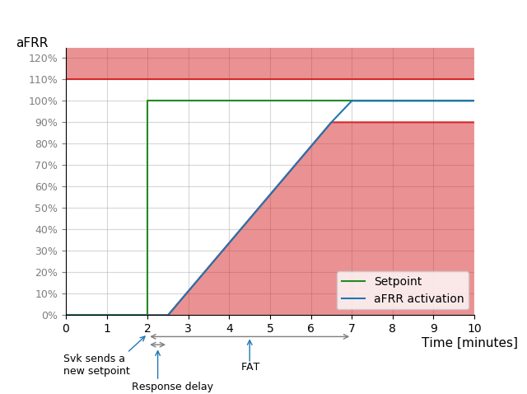

Figure 1: Definition of response delay time and full activation time (FAT). During activation, the response from the unit or group may not fall within the red area. The red area is determined by the capacity that the aFRR prequalification pertains to, see Table 1. A range of $±$ 10% of the setpoint is used in the figure. The blue curve represents an example of an approved response, given a setpoint according to the green curve. The response delay time is 30 seconds, followed by linear activation.

## 1.3 Activation

Full activation time (FAT[1]) is defined as the time it takes from when Svk sends a new setpoint to when the unit or group delivers according to the new setpoint, as illustrated in Figure 1.

Neither the FAT nor the deactivation time for the unit or group may exceed the maximum FAT permitted. This means that when a setpoint change is sent, the unit or group must deliver aFRR according to the new setpoint no later than 5 minutes afterwards. This applies to all setpoint steps, regardless of whether the step is 1 MW or maximum aFRR capacity. The step at which activation takes the longest defines the FAT for the unit or group.

The unit's/group's response may not fall in the red area in Figure 1 during activation. An example of an approved activation is the blue curve in Figure 1.

When activating aFRR the maximum over-delivery may not exceed $±$ 10% of the setpoint, as illustrated in Figure 2.

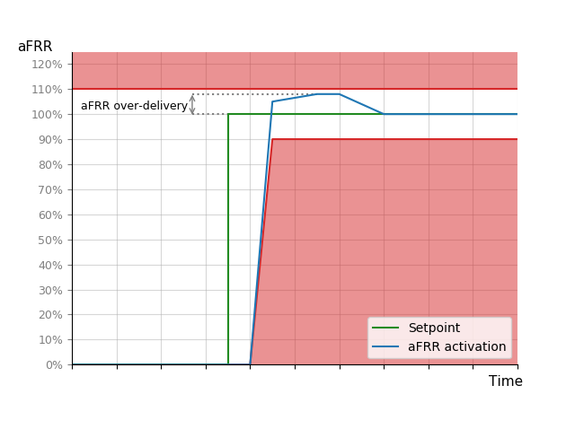

Figure 2: Illustration of definition of over-delivery and the permitted over-delivery interval during aFRR activation. The permitted interval is $±$ 10% of the setpoint

## 1.4 Rapid changes to setpoint

The term “rapid changes to setpoint” is used when one or more new aFRR setpoints are received before a time corresponding to FAT has passed since the most recent received setpoint. In the case of numerous consecutive rapid changes to the setpoint, the unit or group must still be able to fulfil the requirements described above. This means that the delivery of aFRR must fulfil the requirements in Table 1 within 5 minutes of the latest change to the setpoint.

## 1.5 Endurance

The volume of aFRR for which the unit or group has been procured must be available throughout the entire delivery period. In terms of aFRR the unit or group must be able to deliver the maximum aFRR capacity for up-regulation and down-regulation for at least one hour.

## 1.6 Loss of communication

In the event of real-time communication disruptions with Svenska kraftnät, the unit or group must maintain an activation that corresponds to the most recent setpoint received.

## 1.7 Measurement system requirements

The minimum active power measurement requirements for the unit or group when delivering aFRR is provided below. The requirements for resolution and sampling time are presented in Table 2.

Table 2: Requirements for measurement resolution and sampling time of active power.

|  |  |  |
| --- | --- | --- |
| **Category** | **Resolution** | **Sampling time** |
| N/A | 0.1 MW | 5 s |
|  |  |  |

The measurement accuracy requirement differs depending on the size of the resource as seen in Table 3.

Table 3: Requirement for measurement accuracy of active power.

|  |  |  |
| --- | --- | --- |
| **Category** | **Rated power** | **Accuracy** |
| 1 | <2 MW | $±$ 5% |
| 2 | 2-10 MW | $±$ 1% |
| 3 | >10 MW | $±$ 0.5% |
|  |  |  |

## 1.8 Calculating available capacity

Available capacity is calculated according to Equations 1 – 4. If a more precise method for calculating available capacity is available it may be used, in which case the calculation method must be reported in the application form and be approved by Svenska kraftnät in the prequalification process for provision of aFRR.

Equation 1: Calculating available capacity for ${aFRR}_{i}^{up}$:

$${aFRR}_{i}^{up}=\max\left(min\left(aFRR_{i, sold}^{up}; ∆P_{i, max{up}}-P_{i, ancillary service}^{up}\right);0\right)$$

Equation 2: Calculating available capacity for $aFRR_{total}^{up}$:

$aFRR_{total}^{up}= \sum_{i=1}^{n}{aFRR_{i}^{up}}$

Equation 3: Calculating available capacity for ${aFRR}_{i}^{down}$:

$${aFRR}_{i}^{down}=max⁡\left(min\left(aFRR_{i, sold}^{down}; ∆P_{i, max{down}}-P_{i, ancillary service}^{down}\right);0\right)$$

Equation 4: Calculating available capacity for $aFRR_{total}^{down}$:

$$aFRR_{total}^{down}= \sum_{i=1}^{n}{aFRR_{i}^{down}}$$

In which:

${aFRR}_{i}^{up}$ = aFRR capacity for up-regulation (MW), for unit i

${aFRR}_{i}^{down}$ = aFRR capacity for down-regulation (MW), for unit i

$aFRR_{total}^{up}$ = the sum of aFRR up-regulation per provider and bidding zone for the n units providing aFRR in the bidding zone

$aFRR_{total}^{down}$ = the sum of aFRR down-regulation per provider and bidding zone for a the n units providing aFRR in the bidding zone

$aFRR_{i, sold}^{up}$ = aFRR up-regulation capacity for unit i (MW) procured on the market

$aFRR_{i, sold}^{down}$ = aFRR down-regulation capacity for unit i (MW) procured on the market

$∆P_{i, max.{up}}$ = the maximum up-regulation capacity (MW), of unit i. The up-regulation capacity is the capacity to increase production or reduce consumption

$∆P_{i,max.{down}}$ = the maximum down-regulation capacity (MW), of unit i. The down-regulation capacity is the capacity to reduce production or increase consumption

$P_{i, ancillary service}^{up}$ = the capacity that has been procured for up-regulation for other ancillary services such as FCR or FFR

$P_{i, ancillary service}^{down}$ =the capacity that has been procured for down-regulation on the market for other ancillary services, such as FCR or FFR

# Planning prequalification

Prior to prequalification testing, the following points should be checked by the applicant provider. If necessary, contact with Svenska kraftnät should be established well in advance of the tests.

* Review the applicable regulations described in the Avtal om leverans av balanstjänster and its associated appendixes.
* Ensure that the most recent version of each of the documents is used. Information and documents are available at Svenska kraftnät's website.
* Ensure that all information requested in the application form is available.
* During the Signal testing Svenka kraftnät must participate.
* During the capacity test the provider sends preforms the test by sending signal to the unit or group, but Svenska kraftnät has the right to send an observer to participate in person. Ensure that participation is discussed with the Svenska kraftnät manager responsible (afrr@svk.se) as soon as possible, at least 3 weeks prior to the test. The supplier covers the expenses accrued during testing and shall provide the appropriate equipment. Svenska kraftnät is only responsible for their own costs.
* Ensure that any limitations have been approved by Svenska kraftnät before commencing testing.
* Ensure that the data below can be registered continuously throughout delivery.

Table 4: Summary of measurement and regulation requirements.

|  |  |  |  |
| --- | --- | --- | --- |
|  | Accuracy | Resolution | Recommended sampling time[2] |
| Instantaneous active power | Depending on relevant category in accordance with Table 3 | 0.1 MW | 1 s |
|  |  |  |  |

# Prior to testing

In prequalifying to supply aFRR, two test segments are included, a signal test and a capacity test. The test segments are conducted and documented separately, starting with the signal test. In order to conduct the capacity test, the signal test must get a passing result. The signal test is only needed for new providers or if an existing provider wants to provide aFRR in a new bidding zone. For existing providers it is sufficient to perform the capacity test.

## 3.1 Prior to signal testing

The aFRR provider shall collaborate with Svenska kraftnät to establish the real-time communication signals needed to supply aFRR.

## 3.2 Prior to capacity testing

The following points should be checked prior to testing.

* Enable the unit or group settings to provide active power according to plan.
* Switch off the delivery of FCR throughout the tests if the unit or group is capable of delivering FCR.
* Ensure that the data below is logged during the test.
* Ensure that the equipment for logging data is correctly time synchronized.

Table 5: Summary of test measurements and logging.

|  |  |  |
| --- | --- | --- |
|  | Unit | Recommended sampling time[3] |
| Instantaneous active power | MW | 1 s |
| Available capacity | MW | 1 s |
| Received setpoint | MW | 1 s |
| aFRR regulation permitted[4] | ON/OFF | 1 s |
|  |  |  |

In addition to the above data, significant conditions that have an impact on the test results must be logged during testing. Such data includes, but are not limited to, the following:

* Status identification that indicates which control parameter setting are active if settings can be changed automatically during testing.

With regard to hydro power plants

* Output signal from control unit
* Guide vane opening
* Runner blade angle (Kaplan units)
* Water level above sea level at inlet [m]
* Water level above sea level at outlet [m]

With regard to thermal power plants

* Output signal from control unit
* Turbine control valve opening

With regard to batteries

* State of charge

With regard to units or groups that lack a clearly defined setpoint

* Calculated reference value of active power (baseline)

For other technologies, quantities that may impact test results should be logged.

## 3.3 Prior to the Active control test

The following points should be checked prior to testing.

* Enable the unit or group settings to provide active power according to plan.
* Switch off the delivery of FCR throughout the tests if the unit or group is capable of delivering FCR.
* Ensure that the data below is logged during the test.
* Ensure that the equipment for logging data is correctly time synchronized.

Table 6: Summary of test measurements and logging during the Active control test.

|  |  |  |
| --- | --- | --- |
|  | Unit | Recommended sampling time[5] |
| Instantaneous active power for all units in the regulating object | MW | 1 s |
| aFRR Activated | MW | 1 s |
| Received setpoint | MW | 1 s |
| Received setpoint for all units in the regulating object | ON/OFF | 1 s |

# Prequalification test

## 4.1 Signal test

The signal test is performed remotely together with Svenska kraftnät. The provider does not need to fill out a test report for the test. The evaluation takes place while conducting the test. After concluding the test, Svenska kraftnät will inform the provider whether or not the unit or group has been approved.

The purpose of the signal test is to verify that the signals used when activating aFRR are correctly configured. The test is performed by updating each signal manually, one at a time, upon which the receiving party (in part 1, this is the provider of aFRR and in part 2, the TSO) verifies that the change was received in the operating information system.

In the Signal test the response delay time is determined. There are two options for determining the response delay time:

1. By measuring the response delay time in the Active control test (see 4.2)
2. By using a default value from the provider. This requires documentation that validates the default value.

### 4.1.1 Signals from TSO to provider of aFRR

Svenska kraftnät will change the signals according to Table 7. Following each signal change, the provider shall read the received signal before Svenska kraftnät updates the signal.

If the application only pertains to provision of aFRR for up-regulation or down-regulation, a shortened version of the sequence may be used to test the *aFRR Setpoint* signal, see Table 7.

This part of the signal test does not require the provider to register or save data.

Table 7: Description of how signal test shall be conducted when testing signals from TSO to the provider.

|  |  |  |
| --- | --- | --- |
| **Signal** | **Sequence** | **Verification** |
| aFRR Setpoint | Change the setpoint[6]: 0; 1; 2; max; min; -2, -1, 0  Shortened version up-regulation: 0; 1; 2; max; 0  Shortened version down-regulation: 0; -1; -2; min; 0 | The provider reads the received value and notifies the TSO |
| aFRR Enabled | Turn the signal ON  Turn the signal OFF | The provider reads the received value and notifies the TSO |

### 4.1.2 Signals from aFRR provider to TSO

The provider changes the signals according to Table 8. Following each signal change, Svenska kraftnät will read the received signal before the provider updates the signal.

If the application only pertains to provision of aFRR for up-regulation or down-regulation, a shortened version of the sequence may be used to test the first four signals in Table 8.

This part of the signal test does not require the provider to register or save data.

Table 8: Description of how signal test shall be conducted when testing signals from the provider to the TSO.

|  |  |  |
| --- | --- | --- |
| **Signal** | **Sequence** | **Verification** |
| aFRR Setpoint Confirm  aFRR Capacity Up[7]  aFRR Capacity Down[8]  aFRR Activated | Change the setpoint[9]: 0; 1; 2; max; min; -2, -1, 0  Shortened version up-regulation: 0; 1; 2; max; 0  Shortened version down-regulation: 0; -1; -2, min; 0 | TSO reads the received value and notifies the provider |
| aFRR Remote Control Permit | Turn the signal ON  Turn the signal OFF | TSO reads the received value and notifies the provider |

### 4.1.3 Loss of communication test

Svenska kraftnät will simulate a short disruption to the real time communication with the provider by turning off the setpoint signal (*aFRR Setpoint*). The provider shall read the setpoint in their internal system following the simulated communications disruption and notifies Svenska kraftnät.

## 4.2 Active control test

During the Active control test Svenska kraftnät sends a signal to the provider to update the setpoint value for the whole Regulating object. The provider demonstrates that corresponding aFRR has been activated. The step sequence for the Active control test is presented in Table 9.

Table 9: Step sequence for the Active control test.

|  |  |  |
| --- | --- | --- |
| **Step** | **Time [minutes]** | **aFRR Setpoint[MW]** |
| 0 | 0 | 0 |
| 1 | 5 | X MW[10] |

In Active control test the response delay time can be determined. The response delay time is defined as the time it takes from Svk having sent a new setpoint until the unit/group begins to regulate. To verify that the requirement on the response delay time (<30s) is fulfilled the provider must log and save data from this test. Data that should be logged during the test are presented in Table 6.

## 4.3 Capacity test

The capacity test is divided into two parts. The first part tests the response during up-regulation and the second part tests the response during down-regulation. If the application only pertains to supply of aFRR for up-regulation or for down-regulation respectively, only the corresponding test is conducted. If the application pertains to supply of aFRR for both up- and down-regulation, both tests must be performed.

In the Capacity test the provider sends a signal through their Operational monitoring system (SCADA) to the unit or group. The test can be performed without Svenska kraftnät present however; Svenska kraftnät has the right to send an observer to participate in person during the tests. The result of the test must be reported in a test report compiled by the aFRR provider and be attached to the application with logged data.

### 4.3.1 Up-regulation

During testing the provider will send a sequence of aFRR setpoint changes to the unit or group for which the application pertains. The sequence for up-regulation is shown in Figure 3 and Table 10. In the test, the 20%, 30% and 50% steps are rounded down to the nearest integer. If the application pertains to a maximum aFRR capacity of < 10 MW, the sequence is adapted, see Appendix 1.

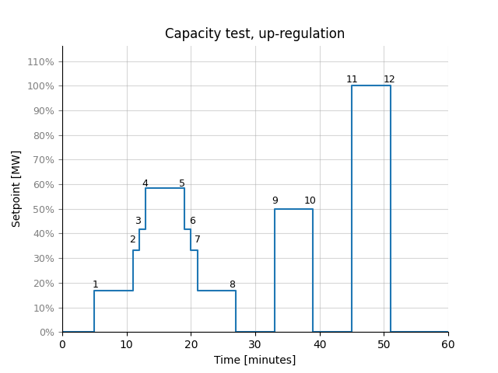

Figure 3: Step sequence for the aFRR up-regulation test.

Table 10: Step sequence for the aFRR up-regulation test.

|  |  |  |
| --- | --- | --- |
| **Step** | **Time [minutes]** | **aFRR setpoint [MW]** |
| 0 | 0 | 0 |
| 1 | 5 | 1 |
| 2 | 11 | 20% of ΔPmax |
| 3 | 12 | 30% of ΔPmax |
| 4 | 13 | 50% of ΔPmax |
| 5 | 19 | 30% of ΔPmax |
| 6 | 20 | 20% of ΔPmax |
| 7 | 21 | 1 |
| 8 | 27 | 0 |
| 9 | 33 | 50% of ΔPmax |
| 10 | 39 | 0 |
| 11 | 45 | 100% of ΔPmax |
| 12 | 51 | 0 |

Once the unit or group has been tested using the above sequence, the full activation time for up-regulation is calculated according to the formula below:

$$FAT=\max\left(Δt_{step 1},Δt_{step 4},Δt_{step 7 }Δt_{step 8},…, Δt_{step 12}\right)+reaction time$$

In which, $Δt$ is the time it takes from when an updated setpoint signal is sent from TSO to when the unit or group supplies according to the setpoint. The response delay time is determined as a part of the Signal test (se 4.1).

### 4.3.2 Down-regulation

During testing the provider will send a sequence of aFRR setpoint changes to the unit or group for which the application pertains. The sequence for down-regulation is shown in Figure 4 and Table 11. In the test, the 20%, 30% and 50% steps are rounded up to the nearest integer. If the application pertains to a maximum aFRR capacity of < 10 MW, the sequence is adapted, see Appendix 1.

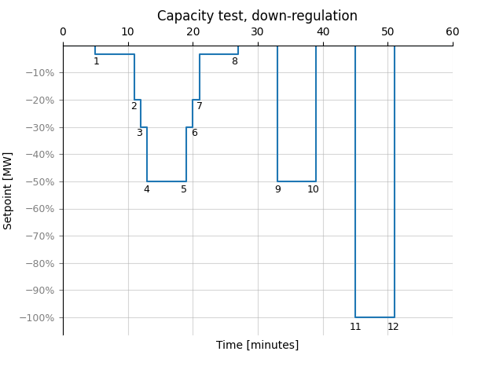

Figure 4: Step sequence for the aFRR down-regulation test.

Table 11: Step sequence for the aFRR down-regulation test.

|  |  |  |
| --- | --- | --- |
| **Step** | **Time [minutes]** | **aFRR setpoint [MW]** |
| 0 | 0 | 0 |
| 1 | 5 | -1 |
| 2 | 11 | 20% of ΔPmax |
| 3 | 12 | 30% of ΔPmax |
| 4 | 13 | 50% of ΔPmax |
| 5 | 19 | 30% of ΔPmax |
| 6 | 20 | 20% of ΔPmax |
| 7 | 21 | -1 |
| 8 | 27 | 0 |
| 9 | 33 | 50% of ΔPmax |
| 10 | 39 | 0 |
| 11 | 45 | 100% of ΔPmax |
| 12 | 51 | 0 |

Once the unit or group has been tested using the above sequence, the full activation time for down-regulation is calculated according to the formula below:

$$FAT=max⁡(Δt_{step 1},Δt_{step 4},Δt_{step 7 }Δt_{step 8},…, Δt_{step 12})+reaction time$$

In which, $Δt$ is the time it takes from when an updated setpoint signal is sent from TSO to when the unit or group supplies according to the setpoint. The response delay time is determined as a part of the Signal test (se 4.1).

### 4.3.3 Endurance test

For units or groups with limited energy reservoirs (LER), i.e. all technologies with limitations to duration and/or recovery time, an endurance test must be conducted in the direction of the limitation (up- or down-regulation).

The endurance test can be performed in two different ways. The provider can choose one of them.

* The endurance test can be conducted as part of the capacity test by extending the time between steps 11 and 12 from 6 minutes to one hour.
* The provider conducts an endurance test on their own in which they show that they can supply maximum aFRR capacity in the limited direction (up- or down-regulation) for one hour. Any applicable historical data may be sent. The historical data may not be older than one year at the time of application.

# Format for data logging

In order for Svenska kraftnät to be able to review submitted data as smoothly and objectively as possible, the process for this is partially automated. Formatting and file names should therefore follow the specifications below.

The file format for data delivery is the European standard csv-file, character encoding in ASCII where values are delimited by comma (,), decimal separator is point (.) and record delimiter is carriage return (↵ ASCII/CRLF=0x0D 0x0A). Naming format for the file is [Resource]_[Service]_[TestType]_[Area]_[Timezone].csv, where the sub-elements are denoted as follows:

* Resource = Identifier for the resource agreed with reserve connecting TSO.
* Service = Type of service. In this case aFRRUp or aFRRDown.
* TestType = The test performed, eg. CapTest och ActiveCont.
* Area = The bidding area where the resource is located. The bidding are either SE1, SE2, SE3 or SE4.
* Timezone = The time zone used for logging, e.g. CET/CEST or UTC.

Example of file name:

UnitG1_aFRRUp_ CapTest_SE3_UTC.csv

Data records are provided in the following format:

DateTime, InsAcPow, …

[DateTime1],[record1_1],[record1_2], … ,[record1_X]

[DateTime2],[record2_1],[record2_2], … ,[record2_X]

etc.

Columns to be included are specified below, including title row and data type.

* DateTime = Date and time on the format YYYYMMDDThhmmss.nnn where n are decimal fractions of a second e.g. 20200601T093702.302
* InsAcPow = Double with at least two decimals of instantaneous active power in MW e.g. 120.50
* AfrrSetP = Double with at least two decimals of aFRR setpoint in MW, e.g. 20
* AfrrAct = Activated aFRR in MW, specified as a double with at least two decimals e.g. 20.12
* AfrrUpCap = Available capacity for aFRR upward regulating in MW, specified as a double with at least one decimal, e.g. 20.1
* AfrrDownCap = Available capacity for aFRR downward regulating in MW, specified as a double with at least one decimal, e.g. 20.1
* ContStatusAfrr =Control signal indicating whether the unit or group is available for aFRR, binary value indicating if the controller is enabled (=1) or not (=1).

An example of how a csv-file should be structured for the capacity test is shown in Figure 5.

Figure 5: Example of how the logged drift data is to be reported during the capacity test for upward regulation

Figure 5: Example of how the logged drift data is to be reported during the capacity test for upward regulation

DateTime, InsAcPow, AfrrSetP, AfrrAct, AfrrUpCap, ContStatusAfrr

20200601T093702.302, 120.50, 20, 20.12, 20.1, 1

20200601T093703.302, 120.50, 20, 20.12, 20.1, 1

20200601T093704.302, 115.30, 20, 20.12, 20.1, 1

20200601T093705.302, 111.00, 20, 20.12, 20.1, 1

Appendix 1 – Capacity test step sequence

The full capacity test described in 4.2. The capacity test can only be applied to units or groups that prequalify for a maximum aFRR capacity of 10 MW or more. If the application pertains to the prequalification of a smaller aFRR volume, the step sequences are adjusted.

The tables below describe how the step sequence is adjusted. Different tables are applicable for up- and down-regulation.

## Maximum aFRR capacity of 1 MW, up-regulation

|  |  |  |
| --- | --- | --- |
| **Step** | **Time [minutes]** | **aFRR setpoint [MW]** |
| 0 | 0 | 0 |
| 1 | 5 | 1 |
| 2 | 11 | 0 |

## Maximum aFRR capacity of 1 MW, down-regulation

|  |  |  |
| --- | --- | --- |
| **Step** | **Time [minutes]** | **aFRR setpoint [MW]** |
| 0 | 0 | 0 |
| 1 | 5 | -1 |
| 2 | 11 | 0 |

## Maximum aFRR capacity of 2-3 MW, up-regulation

|  |  |  |
| --- | --- | --- |
| **Step** | **Time [minutes]** | **aFRR setpoint [MW]** |
| 0 | 0 | 0 |
| 1 | 5 | 1 |
| 2 | 11 | 0 |
| 3 | 17 | ΔPmax |
| 4 | 23 | 0 |

## Maximum aFRR capacity of 2-3 MW, down-regulation

|  |  |  |
| --- | --- | --- |
| **Step** | **Time [minutes]** | **aFRR setpoint [MW]** |
| 0 | 0 | 0 |
| 1 | 5 | -1 |
| 2 | 11 | 0 |
| 3 | 17 | ΔPmax |
| 4 | 23 | 0 |

## Maximum aFRR capacity of 4-9 MW, up-regulation

|  |  |  |
| --- | --- | --- |
| **Step** | **Time [minutes]** | **aFRR setpoint [MW]** |
| 0 | 0 | 0 |
| 1 | 5 | 1 |
| 2 | 11 | 2 |
| 3 | 12 | 3 |
| 4 | 13 | 4 |
| 5 | 19 | 3 |
| 6 | 20 | 2 |
| 7 | 21 | 1 |
| 8 | 27 | 0 |
| 9 | 33 | 50% of ΔPmax |
| 10 | 39 | 0 |
| 11 | 45 | 100% of ΔPmax |
| 12 | 51 | 0 |

## Maximum aFRR capacity of 4-9 MW, down-regulation

|  |  |  |
| --- | --- | --- |
| **Step** | **Time [minutes]** | **aFRR setpoint [MW]** |
| 0 | 0 | 0 |
| 1 | 5 | -1 |
| 2 | 11 | -2 |
| 3 | 12 | -3 |
| 4 | 13 | -4 |
| 5 | 19 | -3 |
| 6 | 20 | -2 |
| 7 | 21 | -1 |
| 8 | 27 | 0 |
| 9 | 33 | 50% of ΔPmax |
| 10 | 39 | 0 |
| 11 | 45 | 100% of ΔPmax |
| 12 | 51 | 0 |

1. Acronym for Full Activation Time
2. The minimum sampling time requirement is listed in Table 2.
3. Pertains to the recommended data sampling time saved during the test. Slower sampling times can be permitted, but must not exceed the maximum sampling time for normal operations (10 seconds).
4. Signal from provider to TSO that indicates whether aFRR regulation is permitted, in real time.
5. Pertains to the recommended data sampling time saved during the test. Slower sampling times can be permitted, but must not exceed the maximum sampling time for normal operations (10 seconds).
6. If the application pertains to a maximum aFRR capacity of < 3 MW, the signal test is adapted accordingly.
7. If the application only pertains to supply of aFRR for down-regulation, this step does not need to be conducted.
8. If the application only pertains to supply of aFRR for up-regulation, this step does not need to be conducted.
9. If the application pertains to a maximum aFRR capacity of < 3 MW, the signal test is adapted accordingly.
10. X corresponds to a step of approximately a 1-10 MW and are determined together with the provider prior to the test.